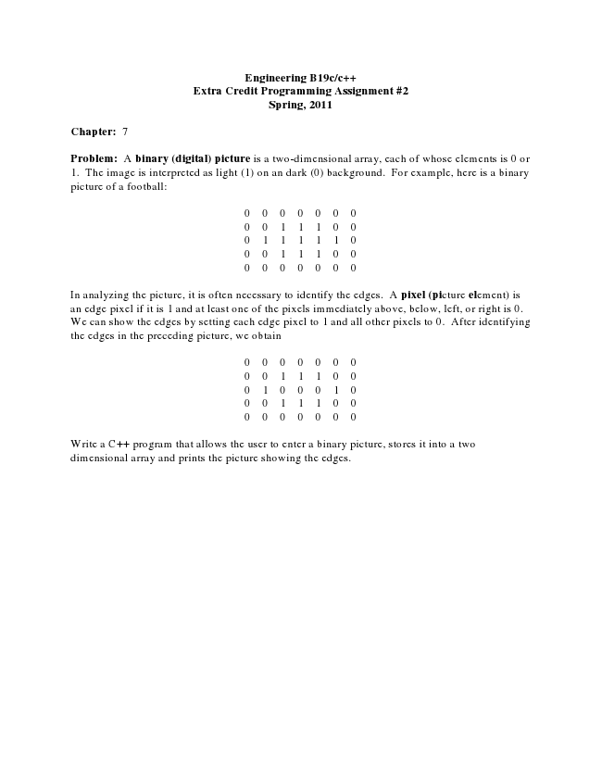

**Engineering B19c/c++ Extra Credit Programming Assignment #2 Spring, 2011**

**Chapter: 7**

Problem: A binary (digital) picture is a two-dimensional array, each of whose elements is 0 or 1. The image is interpreted as light (1) on an dark (0) background. For example, here is a binary picture of a football:

0 0 0 0 0 0 0 0 0 1 1 1 0 0 0 1 1 1 1 1 0 0 0 1 1 1 0 0 0 0 0 0 0 0 0

In analyzing the picture, it is often necessary to identify the edges. A pixel (picture element) is an edge pixel if it is 1 and at least one of the pixels immediately above, below, left, or right is 0. We can show the edges by setting each edge pixel to 1 and all other pixels to 0. After identifying the edges in the preceding picture, we obtain

0 0 0 0 0 0 0 0 0 1 1 1 0 0 0 1 0 0 0 1 0 0 0 1 1 1 0 0 0 0 0 0 0 0 0

Write a C++ program that allows the user to enter a binary picture, stores it into a two dimensional array and prints the picture showing the edges.